FrontPanel: Tangible User Interface for Touch-Screens Dedicated to Elderly

【Summary】:

We will introduce FrontPanel, a tangible user interface that enhances the capabilities of the iPad. More specifically, FrontPanel is designed for older people who have difficulty interacting with touch screen tablets due to lack of accessibility.

【FrontPanel】：Similar to the old transistor radio, the FrontPanel contains a total of six knobs, switches and sliders.

**Toggle Switch: Home Button**

**Rocker Switch: Closing Applications**

**Push Button: Moving from one Page to Another and Select a Program**

**Keypad Switch: Menu Navigation**

**Encoder Switch: Control Volume**

**Slider: Zoom Function**

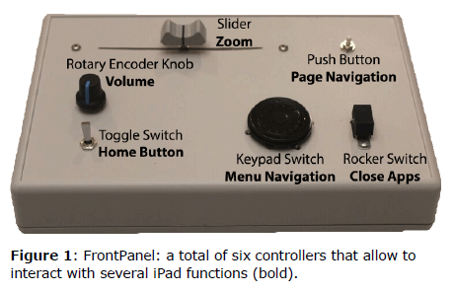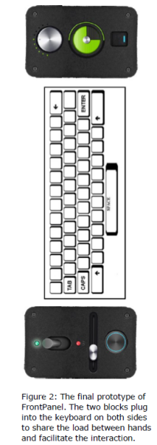

**【Subjective analysis】:**

Next ： Quantitative analysis of the accuracy and time of the operation.